



Solution Design Document

SmartForm

Version1.0

**February 25, 2019**

Document History

|  |  |  |  |  |
| --- | --- | --- | --- | --- |
| Revision | Description | Date | Prepared By | Reviewed By |
| 1 | Solution Design Document – Initial draft | 27/02/2019 | Siva/ Mayuresh/ Koteshwararao | Mohan |

Table of Contents

1 Introduction 4

1.1 Document Purpose 4

1.2 In Scope 4

1.3 Out of Scope 4

1.4 Relevant Documents (Current Situation/Environment) 5

1.5 Assumptions 5

2 Systems Overview 6

2.1 Applications and Systems 6

Type of access required – SSO, credentials etc. 6

2.2 Applications Interfacing 6

3 Analysis 7

3.1 High-level components 7

3.2 Narrative Use Case and Detailed Process 7

3.3 Requirements 8

4 Solution Overview 10

4.1. Solution Diagram 10

5 Data Structure ER Diagram 14

5.1. Data Structure 14

6 Pseudo Code for Transactions 14

7 Inputs and Outputs 14

7.1. Inputs 14

7.2. Outputs 14

8 Assets 14

9 Robot Schedule 14

10 Workflow Modules 14

SmartForm Workflow 14

a. Exceptions 15

11 Logs 16

12 Reusable Components: 16

13 Coding Standards 16

14 Frequency – Put in Scheduling section 16

15 SLA- Put in Scheduling section 16

16 Report Generation 17

# Introduction

This document will provide solution and technical design of Data Management - SmartForms.

## Document Purpose

The purpose of this document is to explain the technical design and overview of SmartForms implementation for the Data management.

Its main purpose is to –

* Provide the link between the functional specification and the detailed technical design documents
* Detailed functionality provided by each component or group of components and show how the various components interact in the design
* Provide a basis for SmartForms detailed design and development
* This document is not intended to address installation and configuration details of the actual implementation. Installation and configuration details are provided in technology guides produced during project

As is true with any high-level design, this document will be updated and refined based on changing requirements.

## Distribution List

|  |  |  |
| --- | --- | --- |
| Name | Role | Notes |
| Orla Weare - Business  Ashok Verma – Technology | Project Owner | Overall project owner and Level 1,2 escalation |
| Abhinav Sharma | Business Analyst | Point of contact for process related queries |
| Nitin Agarwal- DM Smart Form  Ewa Ziemkowska- Smart Form | Business PM | Point of contact for process related queries |
| Gary Tessler and Malissa Ford | Tech Solutions PM | Point of contact for process related delivery |
| KJ Davis | Tech Solutions | Point of contact for process related delivery |
| Mohan Patil | PM | Point of contact for process related delivery |
| Siva Audina | Tech Architect | Point of contact for process related delivery |

## In Scope

* All transaction for Data management which includes Personal and Job changes
* Self-Service: Below is the list of transactions:

Address

Contact Details

Disability

Emergency contact

Ethnicity

Gender

Preferred Name

Veteran Info

Business title

Company

Department

FCLM Area and FCLM job

Full time - Part Time

Pay group

Product Line

Shift Pattern and ADP shift

Supervisor change

* Non-Self-service: Below is the list of non-self service transaction

Bank Account details

Bank Account Number

CRI National ID

Date of Birth

Educational qualification

Legal Name

Marital Status

National ID Upload

SSN/SIN/National ID

Visual Survey Conducted

Work Permit Details

Agency

Amazon Discount Code

Business Unit

Compensation

EA ( Executive Assistance )

Eligibility

Employment Date

Job Code

Location

M&A  Hire/Re-Hire

Office Location Change

Part time Work Arrangement- FWA

Pay rate

Promotions

Public Transportation Reimbursement

Seasonal-Individual

Shift- Individual(CR)

Standard Hours

Status Change

Suspension

Telecommuting-Individual

* 1. Out of scope
* Request with no valid data
* Requests with pending approvals
* Infrastructure
* Deployment
* Workflow
* Flat file integration
  1. Assumptions
* General Assumptions
  + All environments will be configured and setup by Amazon
  + All developmental software’s will be provided by Amazon
  + Development infrastructure will be provided and maintained by Amazon
  + Training on Amazon tools and software’s will be provided to LTI
  + Alpha and Beta environment access will be provided to LTI
  + Third party application access will be provided to LTI by Amazon
  + Post production all environments and Applications/Databases will be maintained by Amazon
* Responsive UI Development is based on the following assumptions:
  + HTML 5.0 and CSS 3.0 development for 10 Templates (No CSS processors)
  + Browser compatibility details (latest versions of Chrome, Firefox and IE 11+) will be shared to LTI
  + No Compatibility a MAC OS and Bro
* Integration is based on the following assumptions:
  + SSO details will be shared by Amazon
  + After authentication Token will be shared with SMF application. SMF will validate the Token and provide access to the user.
  + SMF expects employee ID through the header which will be used to identify role and
  + Amazon will share the flat file dump with LTI
  + PeopleSoft access will be provided by Amazon
  + WF API (TT) details will be shared by Amazon
  + For notification, SMTP details will be shared by Amazon

1. Systems Overview­­

This Section depicts the Application/System being used in current process and what Application/System will be used after automation implementation.

* 1. Applications and Systems

|  |  |
| --- | --- |
| Applications | URL *(if any)* |
| SmartForms | Alpha:  Beta:  Gymea:  Delta: |
| PeopleSoft | Alpha:  Beta:  Gymea:  Delta: |

Type of access required – SSO, credentials etc.

* 1. Applications Interfacing

|  |  |
| --- | --- |
| Applications/Systems | Interfacing mechanism |
| SmartForms | Through SmartForms UI |
| PeopleSoft |
| Remedy TT |
| RPA |

# Analysis

## High-level components



* 1. Narrative Use Case and Detailed Process

|  |  |
| --- | --- |
| Use Case Name | Data Management - SmartForms |
| Goal in Context | Smart Form is a dynamic web-based form solution used to collect, navigate, validate and to eliminate manual work, defects with automation |
| Pre-conditions | User entered data should be valid and must fulfill the requirement of automation |
| Success End Condition | People soft will be updated with user entered data either through self-service or automation |
| Primary Actor | SmartForm, RPA and PeopleSoft |

* 1. Requirements

GUI / SCREEN DESIGN FOR WEB APPLICATIONS:

| GUI Aspects | Considerations / Alternatives | Details and (optional) Rationale |
| --- | --- | --- |
| Usage of Frames | Yes / No |  |
| Usage of Style sheets (CSS) | Yes |  |
| Sitemap | No |  |
| Menu organization and Navigation | Top Menu |  |
| Technologies | HTML5, CSS3, Angular6, Bootstrap4 and NodeJs |  |
| Colour Scheme | Single scheme for all pages |  |
| Images and their size and quality | PNG / JPEG  Size |  |
| Max page size | Kbs |  |
| Usage of Page ID apart from Page title | Not required |  |
| Screen Resolution | 1366x768, 800 x 600, 1024 x 768, 1024×576, 1152×648, 1280×720, 1366×768, 1600×900, 1920×1080 |  |
| Browser support | IE 10+, Chrome, Firefox, Safari |  |
| Validation | Common validation / Individual validation |  |
| Error message display locations | TBD |  |
| Search Facility and Technology | NA |  |
| Support for search engines | NA |  |

Services DESIGN FOR WEB APPLICATIONS:

| GUI Aspects | Considerations / Alternatives | Details and (optional) Rationale |
| --- | --- | --- |
| Technologies | Java 1.8, Spring 5+  Hibernate 4.0  MySQL 7.0 |  |
| Validation | Common validation / Business Rules validation |  |
| Error message | TBD |  |
| Search Facility and Technology | NA |  |
| Support for search engines | NA |  |

INTEGRATION DESIGN FOR WEB APPLICATIONS:

|  |  |  |
| --- | --- | --- |
| Integration Aspect | Consideration/ Alternatives | Details and (optional) Rationale |
| Restful web service | Yes/No |  |
| Technologies | JDK 1.8, Spring 5, Maven, Eclipse, SVN/GitHub, Tomcat |  |
| Validations | Common validation / Individual validation |  |
| Error message | TBD |  |

CODING UI:

| Code Element | Considerations / Alternatives | Details and (optional) Rationale |
| --- | --- | --- |
| Documentation | Angular.io |  |
| HTTP Method | GET, POST |  |
| Common Header & Footer and Includes | Yes |  |
| Session Cleaning |  |  |
| Database Connection |  |  |
| Screen Validations | Date, Trim, Maxsize, Browser Compatibility, Format, Field type |  |
| Security | Restricting intermediate URL access for valid & invalid users |  |
| Folder/ Package Structure | Yes |  |

CODING Services:

| Code Element | Considerations / Alternatives | Details and (optional) Rationale |
| --- | --- | --- |
| Documentation | Java Docs |  |
| HTTP Method | GET, POST |  |
| Session Cleaning |  |  |
| Database Connection |  |  |
| Security | Restricting intermediate URL access for valid & invalid users |  |
| Folder/ Package Structure | Yes |  |
|  |  |  |

*Final Solution design will be ready once the clarification is received.

# Solution Overview

## 4.1. Solution Diagram

1. Smart Form Solution Flow

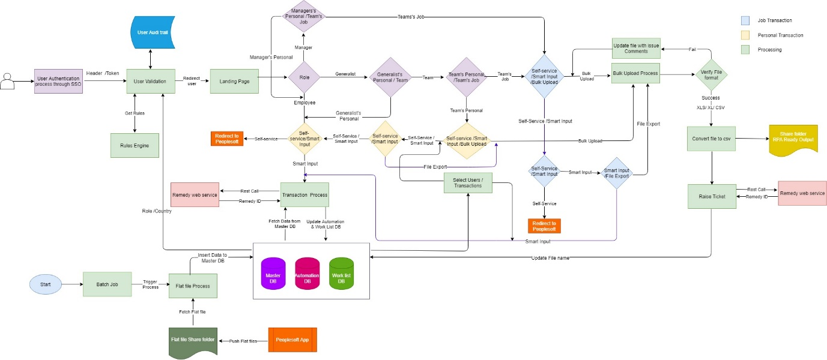

Figure 1 Smart Form Solution Flow Diagram

* User choose smart form action from other portal and SSO helps user to login in smart form portal
* User will land on landing page and based on his/her role and country/region applicable transactions and fields will be visible to him/her
* There are two types of transaction categories one is personal transactions and second one is Job transactions
* Transactions are further divided into Self Service, Non-Self-Service and Bulk Upload
* For self-service transactions, user will get redirected people portal or if smart input is required then will create a ticket for it and update the worklist DB and automation db.
* For non-self-service transactions, user will provide input (smart input or form data) from smart form. Ticket will get created in ‘Remedy’ and ticket id will get updated in ‘Worklist DB’ and new entry will get created in transaction table with worklist Id.
* For bulk upload, user can upload CSV, Excel, XLS. Files uploaded for bulk upload transactions
* Employee can only change is personal details. Manager can change his own personal details and others job details, but manager is not allowed to change others personal details. Generalist can do personal as well as job details changes for others.
* System is continuously synching automated data with people soft data by running batch jobs.

1. Bulk Upload

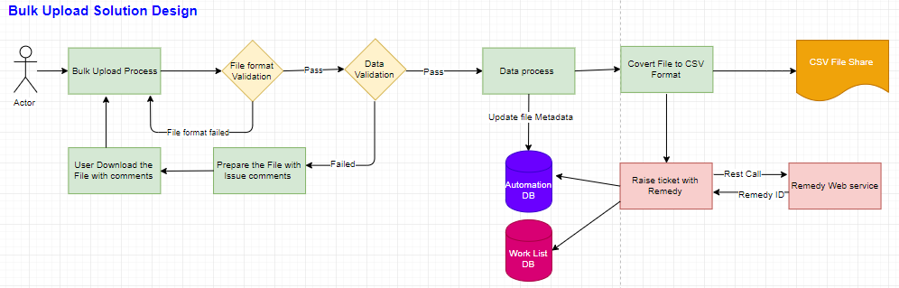

* Bulk upload is the functionality to perform single or multiple transactions for multiple employees.
* Requestee can upload either .csv, .xls or .xlsx files and that file can contain record for single transaction or multiple transaction.
* User can upload file of any size but internally Integration system will have to convert it into files of size max 400 kb.
* System will first validate the file data and if even a single record is invalid then system will add comment for invalid record and make file available for user to download. User can then make correction into data and re-upload file for bulk upload
* Ticket will be created in Remedy and respective entry will be made in Worklist DB and file will get uploaded into shared drive and its path will get stored into Automation table

1. Remedy service

TBD

1. Single Sign On (SSO)

TBD

1. Notification service

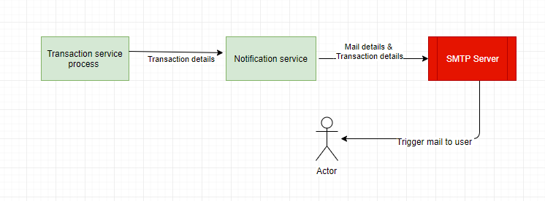

* Transaction service is responsible for sending notifications to requester or to approver
* Transaction service process provides transaction details to notification service and notification will be send using SMTP server by passing mailing details and transaction details

1. Configuration service

TBD

# Different type of transactions

|  |
| --- |
| **Transaction type**: Self Service |
| * After successful login, user will be redirected to landing page. * Landing page will be rendered with user data such as personal, transaction requests made by him. * User will select the transaction and will be navigated to PeopleSoft portal guided by provided link. |
| **Technical view**: During SSO login, behind the scenes user data will be captured and will be saved as meta data, using which fields get populated.  Integration API will fetch the requested metadata from Master DB. Angular route resolver will fetch corresponding data from API and populate data into the page before navigation. |

|  |
| --- |
| **Transaction type**: Smart Input |
| * After successful login, user will be redirected to landing page. * Landing page will be rendered with user data such as personal, transaction requests made by him. * User will be choosing the type of transaction which he wants to make and provides the Smart Input to complete the transaction. |
| **Technical view**: During SSO login, behind the scenes user data will be captured and will be saved as meta data, using which fields get populated.  Integration API will fetch the requested metadata from Master DB. Angular route resolver will fetch corresponding data from API and populate data into the page before navigation.  Required fields will be validated, user entered data will be processed after meeting all the business rules/validation requirements. Remedy ticket will be created and corresponding info will be inserted to Automation DB along with Worklist and ticket IDs. |

|  |
| --- |
| **Transaction type**: Bulk – Smart Input |
| * After successful login, user will be redirected to landing page. * Landing page will be rendered with user data such as personal, transaction requests made by him. * User (Manager/Generalist) will be choosing the type of transaction which he wants to make and provides the Smart Input for maximum of 5 employee under their unit. |
| **Technical view**: During SSO login, behind the scenes user data will be captured and will be saved as meta data, using which fields get populated.  Integration API will fetch the requested metadata from Master DB. Angular route resolver will fetch corresponding data from API and populate data into the page before navigating to landing page.  Required fields will be validated, user entered data will be processed after meeting all the business rules/validation requirements. Remedy ticket will be created and corresponding info of 5 members of his unit will be inserted to Automation DB along with Worklist and ticket IDs. |

|  |
| --- |
| **Transaction type**: Bulk – File Export |
| * After successful login, user will be redirected to landing page. * Landing page will be rendered with user data such as personal, transaction requests made by him. * User will be choosing the type of transaction which he wants to make and provides the Smart Inputs for more than 5 transactions. |
| **Technical view**: During SSO login, behind the scenes user data will be captured and will be saved as meta data using which we prepopulate the fields.  Integration API will fetch the requested metadata from Master DB. Angular route resolver will fetch corresponding data from API and populate data into the page before navigating to landing page.  Required fields will be validated, user entered data will be processed after meeting all the business rules/validation requirements. CSV will be created and placed on shared folder. Remedy ticket will be created and CSV file name will be inserted to Automation DB along with Worklist and ticket IDs. |

|  |
| --- |
| **Transaction type**: Bulk – File Upload |
| * After successful login, user will be redirected to landing page. * Landing page will be rendered with user data such as personal, transaction requests made by him. * User will be choosing the type of transaction which he wants to make and provides the Smart Input to complete the transaction. |
| **Technical view**: During SSO login, behind the scenes user data will be captured and will be saved as meta data using which we prepopulate the fields.  Integration API will fetch the requested metadata from Master DB. Angular route resolver will fetch corresponding data from API and populate data into the page before navigating to landing page.  Uploaded file will be validated for its type, size and format. Remedy ticket will be created and file name will be inserted to Automation DB along with Worklist and ticket IDs. |

# SmartForm Wireframes



# Admin Screen Wireframes



# Where are the details for the worklist?

# Data Structure ER Diagram – nothing there?

# Master data flow should come?

# Input Processing and Output

# Input

* User entered data either Individual or Bulk data through Smart Form



# Processing



# Output

* User request can be self-service or automated through RPA and data will be updated to PeopleSoft

# API

* WFA API
* SMTP

# Assets

* Smart Form takes help of:
  + PeopleSoft
  + Remedy (WFA API)
  + SMTP

# Workflow Modules

## SmartForm Workflow

* Employee land on Smart Form page
* Page is pre-populated with requestor indicative detail and probing navigation
* Is this about you or someone else
* Individual Vs Bulk Request
* Is this about transaction for which smart input can taken
* Employee write data in form which will create a worklist or Excel o/p
* RPA ready o/p
* Validated o/p for ticketing
* Validation of transaction. Can this be done without Remedy Ticketing
* Pure Redirect to (TT)
* Pure Redirect to Self- Service
* Fake self Service
* RPA ready o/p
* Validation of request and attachment.
* Convert the bulk request into a worklist or Excel
* RPA ready o/p
* Escape Valve

## Exceptions

|  |  |
| --- | --- |
| Exception | Description |
| Application Exception | Peoplesoft / Salesforce applications are down |
| Business Exception | Yet to receive from the Client |

# Logs

* Log information can be stored in Server log folder.
* Logs will be captured for each transaction from smart form

Transaction Log would have the following details

* Transaction Name
* Transaction time
* Transaction Exception Details (In case of any errors)

# Reusable Components:

* Wireframes
* Visual Designs
* HTML and CSS
* UI Common Components
* Common Services
  + Remedy Service
  + RPA Service
  + Notification Service
  + Work List Service
  + Rules Service
  + Read Flat File Service
  + Admin Service

# Coding Standards



# Frequency – Put in Scheduling section

* NA

# SLA- Put in Scheduling section

SLA is to verify all the applications received on the same day (TBC)

# Report Generation

# Share SQL queries to get below reports

1. Transaction Report: Capture detail of all transaction happens inside SMF



1. Ticketing detail report: It can be task report to capture all ticket or case id that come out of interaction with SMF.



# Reference Documents

|  |  |
| --- | --- |
| File Description | File Reference |
| Functional Requirement Document |  |
| Discovery Package |  |
| Transaction Document |  |